# INTRODUCTION

### 1. ​INTRODUCTION

Diagnosing chronic diseases, such as diabetes, cardiovascular issues, and respiratory disorders, presents a considerable challenge due to the intricate nature of symptoms and disease progression. Traditional diagnostic approaches, though effective, often involve labor-intensive manual analysis and interpretation, which can be susceptible to errors and inefficiencies. With the increasing incidence of chronic conditions worldwide, there is an urgent need for innovative methods to enhance the accuracy and efficiency of diagnostics.

###### INTRODUCTION

Artificial intelligence (AI) has emerged as a pivotal technology in healthcare, offering advanced solutions to support and improve diagnostic processes. AI-driven diagnostic support systems employ sophisticated Machine Learning (ML) and Deep Learning (DL) techniques to analyze large volumes of medical data with greater precision. These systems are capable of automating the evaluation of medical images, detecting intricate patterns, and generating predictions, which helps reduce the burden on healthcare professionals and enhances diagnostic performance.

Machine Learning encompasses a variety of techniques, including neural networks and fuzzy logic, which contribute to automating and optimizing diagnostic workflows. These methods enable AI systems to learn from data and continually improve their predictive accuracy. Deep Learning, a specialized area within ML, utilizes Convolutional Neural Networks (CNNs) to conduct advanced image analysis without the need for manual feature extraction, leading to more accurate detection and classification of disease-related features in medical images.

The application of AI in chronic disease detection has the potential to significantly transform healthcare by providing more accurate and timely diagnosis, facilitating early intervention, and improving overall patient care. However, challenges remain, such as issues with data quality, algorithm transparency, and integration into existing healthcare practices. Addressing these challenges is crucial for maximizing the benefits of AI-driven diagnostic systems.

A detailed review of AI-driven diagnostic support systems for chronic disease detection, highlighting recent technological advancements, evaluating their effectiveness, and exploring current limitations. By examining the impact of AI on chronic disease diagnostics and suggesting future research avenues, this review aims to advance the development and integration of AI technologies in healthcare.

###### MOTIVATION

**Improved Patient Outcomes**: Leveraging AI in diagnostics aims to enhance patient care by enabling early detection of chronic illnesses, improving prognosis through timely intervention.

**Enhanced Diagnostic Accuracy**: Advanced machine learning algorithms analyze complex data, reducing the likelihood of human error and increasing diagnostic precision.

**Early Detection of Chronic Diseases**: The system focuses on identifying diseases such as cancer, heart disease, and diabetes in their early stages, when treatment is most effective.

**Comprehensive Data Analysis**: By integrating patient medical history, test results, and imaging data, the system provides a holistic view for better diagnosis.

**Actionable Insights for Decision-Making**: The tool offers predictive analytics and risk assessments, enabling healthcare providers to make informed decisions swiftly.

**Integration with EHR Systems**: Seamless compatibility with electronic health record systems ensures widespread adoption and streamlined workflows in healthcare facilities.

**Workload Reduction for Medical Professionals**: Automating data analysis and diagnostics allows practitioners to focus on patient care, reducing their workload and preventing burnout.

**Accessibility and Scalability**: The system is designed to be accessible across various healthcare setups, ensuring its impact is broad and scalable.

**Research-Driven Development**: The project emphasizes training the model on diverse datasets to achieve high accuracy and generalizability, addressing biases and ensuring reliability.

**Focus on Real-Time Processing**: Incorporating real-time data processing ensures the system delivers timely insights critical for immediate clinical decisions.

**Engaging User Experience:** Aims to provide users with an engaging and entertaining experience that goes beyond conventional drawing applications.

###### PROBLEM DEFINITION

Chronic diseases such as cancer, heart disease, and diabetes are leading causes of death and disability globally, placing immense pressure on healthcare systems and economies. Early detection of these conditions is critical for successful treatment and improved patient outcomes. However, traditional diagnostic methods often fall short due to their reliance on manual processes that are time-consuming, error-prone, and limited in their ability to analyze complex and voluminous healthcare data. As a result, many chronic conditions are diagnosed at advanced stages, when treatment options are less effective, leading to higher mortality rates and increased healthcare costs. These challenges are compounded by the rising demand on healthcare professionals, who are often overwhelmed with large workloads, further increasing the likelihood of diagnostic delays and errors.

To address these pressing challenges, there is a need for an innovative diagnostic support system powered by artificial intelligence (AI). Such a system can leverage advanced machine learning algorithms to analyze diverse datasets, including medical histories, imaging studies, and laboratory results, with speed and accuracy far beyond human capabilities. The use of predictive analytics and real-time data processing will enable the system to detect early signs of chronic illnesses, providing actionable insights and risk assessments for medical practitioners. This capability not only enhances diagnostic accuracy but also facilitates timely interventions, significantly improving patient outcomes. Moreover, by automating the analysis of complex medical data, the system can alleviate the workload of healthcare professionals, allowing them to focus on patient care and decision-making.

A critical aspect of the proposed system is its seamless integration with existing electronic health record (EHR) systems. This compatibility ensures that the solution is accessible and scalable across diverse healthcare settings, enabling widespread adoption and impact. By streamlining workflows and providing reliable diagnostic support, the system can transform chronic disease management, making it more efficient and effective. Ultimately, this AI-driven solution has the potential to revolutionize healthcare by improving diagnostic precision, reducing the burden on healthcare practitioners, and delivering better outcomes for patients worldwide.

###### OBJECTIVE OF THE PROJECT

#### Problem statement

Chronic diseases such as cancer, heart disease, and diabetes are significant global health challenges due to their high prevalence, severe outcomes, and associated costs. Early detection is critical for improving patient outcomes, yet traditional diagnostic methods, reliant on manual analysis of complex patient data, are often time-consuming, error-prone, and inadequate for handling the growing volume of healthcare information. These limitations lead to delayed diagnoses, reduced treatment efficacy, and increased strain on healthcare systems. An AI-driven diagnostic support system is essential to address these issues by leveraging machine learning algorithms to analyze diverse datasets, identify early disease indicators, and provide actionable insights for timely interventions. By integrating seamlessly with existing electronic health record (EHR) systems, such a solution can enhance diagnostic accuracy, reduce medical practitioners’ workloads, and transform chronic disease management for better patient care and outcomes.

#### Proposed System

The proposed system can be classified into mainly two steps after acquiring the input data from the user who are using our application and the other one is getting the result by processing the input data.. These steps are: Extraction Method and Features estimation and Extraction.

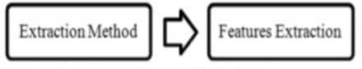

**Fig 1.4.1 Steps of Extraction**

###### ORGANIZATION OF THE REPORT

The report gives the reader a summary of the project and details the methodical execution of the developed working application. It also provides an overview of the project's potential for implementation.

Chapter 1: Introduction is about the AI DRIVEN DIAGNOSTIC CENTER SUPPORT FOR DETECTION OF CHRONIC DISEASES motivation, definition and objective of the project.

Chapter 2: System requirement specifies all the requirements that are needed for developing the application, which includes hardware and software requirements.

Chapter 3: Literature survey details about Chronic diseases detection using Advanced techniques and covers the reason behind developing the project.

Chapter 4: System Design and UML diagrams are shown.

Chapter 5: Entire source code and results of the Implementation are shown.

Chapter 6: All the testing strategies that are involved to test the model, has been described in this section.

Chapter 7: Future enhancement section provides the details about the extension of the project that are to be implemented in the future and what can be added in future.

Chapter 8: References

# SYSTEM

# SPECIFICATIONS

### 2. ​SYSTEM SPECIFICATIONS

###### SOFTWARE SPECIFICATIONS

Software requirements deal with defining software resource requirements and prerequisites that need to be installed on a computer to provide optimal functioning of an application.

These requirements or prerequisites are generally not included in the software installation package and need to be installed separately before the software is installed.

The system should be able to interface with the existing system

* The system should be accurate
* The system should be better than the existing system

###### HARDWARE SPECIFICATIONS

The most common set of requirements defined by any [operating system](http://en.wikipedia.org/wiki/Operating_system) or [software](http://en.wikipedia.org/wiki/Software_application) [application](http://en.wikipedia.org/wiki/Software_application) is the physical computer resources, also known as [hardware,](http://en.wikipedia.org/wiki/Computer_hardware) A hardware requirements list is often accompanied by a [hardware compatibility list](http://en.wikipedia.org/wiki/Hardware_compatibility_list), especially in case of operating systems. An HCL lists tested, compatible, and sometimes incompatible hardware devices for a particular operating system or application. The following sub-sections discuss the various aspects of hardware requirements.

All computer [operating systems](http://en.wikipedia.org/wiki/Operating_system) are designed for a particular [computer architecture](http://en.wikipedia.org/wiki/Computer_architecture). Most software applications are limited to particular operating systems running on particular architectures. Although architecture-independent operating systems and applications exist, most need to be recompiled to run on a new architecture.

The power of the [central processing unit](http://en.wikipedia.org/wiki/Central_processing_unit) (CPU) is a fundamental system requirement for any software. Most software running on [x86 architecture](http://en.wikipedia.org/wiki/X86_architecture) define processing power as the [model](http://en.wikipedia.org/wiki/List_of_microprocessors) and the [clock speed](http://en.wikipedia.org/wiki/Clock_rate) of the CPU. Many other features of a CPU that influence its speed and power, like [bus speed](http://en.wikipedia.org/wiki/Front_side_bus), [cache,](http://en.wikipedia.org/wiki/CPU_cache) and [MIPS](http://en.wikipedia.org/wiki/Instructions_per_second) are often ignored.

**HARDWARE AND SOFTWARE REQUIREMENTS**

###### HARDWARE REQUIREMENTS

* RAM : 8GB
* Processor : Intel ICore
* Hard disk : 2TB

###### SOFTWARE REQUIREMENTS

* Operating System : Windows
* Libraries : Numpy,Pandas, MatplotLib,Seaborn,Scikit Learn,Keras
* Framework : Flask
* Language : Python

# LITERATURE

# SURVEY

### 2. ​LITERATURE SURVEY

###### EXISTING SYSTEM

* + 1. **Evaluation of artifcial intelligence techniques in disease diagnosis and prediction Authors:** Nafseh Ghafar Nia1, Erkan Kaplanoglu1, Ahad Nasab1

**Published Year:** 2023

The research paper "Evaluation of Artificial Intelligence Techniques in Disease Diagnosis and Prediction" provides a comprehensive review of how artificial intelligence (AI) is revolutionizing medical diagnostics. It highlights the critical role of AI, particularly through machine learning (ML) and deep learning (DL), in automating disease detection and improving diagnostic accuracy. By processing complex medical images such as CT scans, X-rays, and MRIs, AI-based models like Convolutional Neural Networks (CNNs) and Support Vector Machines (SVMs) have significantly enhanced the efficiency of disease identification. These technologies reduce physician workloads, minimize errors, and improve early detection rates, especially for conditions such as cancers, cardiovascular diseases, and neurological disorders.

The paper emphasizes the wide-ranging applications of AI in the healthcare sector. For instance, DL models excel in analyzing large datasets and automatically extracting relevant features, making them particularly effective for medical imaging tasks such as segmentation, classification, and fusion. Predictive modeling is another area where AI has proven invaluable, as it helps forecast disease progression and identify at-risk individuals. The study also showcases specific implementations, such as AI frameworks for diagnosing Alzheimer’s disease, Parkinson’s disease, and breast cancer, achieving remarkable levels of accuracy that often surpass human expertise. AI technologies are also used for real-time monitoring of patients, offering personalized insights and enabling more effective health management.

However, the study also discusses significant challenges in implementing AI in medical diagnostics. A major hurdle is the reliance on large, labeled datasets for training AI models, which are not always readily available. Additionally, the complexity of DL architectures and the computational power they require pose significant barriers. Ethical concerns, such as maintaining patient privacy and addressing biases in AI algorithms, further complicate the integration of these technologies into mainstream healthcare. The paper suggests potential solutions, including the use

of data augmentation to expand training datasets and techniques like model compression to reduce computational demands.

Looking ahead, the paper envisions a future where AI becomes an integral part of healthcare, enhancing patient outcomes and optimizing clinical workflows. Advances in AI could lead to more precise diagnostics, personalized treatment plans, and early disease detection, significantly improving global healthcare systems. However, achieving this vision will require collaboration between AI researchers, medical professionals, and policymakers to address current limitations and ethical concerns. The study concludes by emphasizing that with continuous advancements, AI holds the promise of transforming disease diagnosis and prediction into a more efficient, accurate, and accessible process.

* + 1. **Artificial intelligence in disease diagnostics: A critical review and classification on the current state of research guiding future direction**

**Authors**: Milad Mirbabaie , Stefan Stieglitz ,Nicholas R. J. Frick

**Published Year:** 2021

The research paper critically examines the role of artificial intelligence (AI) in medical diagnostics, providing an overview of its current applications and a classification of AI techniques used in healthcare. It highlights how AI can address diagnostic challenges arising from human error, cognitive overload, and time constraints in the medical field. AI systems, such as neural networks and decision trees, are shown to improve diagnostic accuracy, efficiency, and consistency by processing large datasets, integrating data from multiple sources, and applying advanced algorithms.

The paper explores various AI approaches like supervised, unsupervised, and deep learning, emphasizing their applicability to specific diseases and datasets. Supervised learning techniques, such as support vector machines and neural networks, have been widely used for disease prediction and classification. Deep learning, with its ability to process complex, multidimensional data, has been particularly impactful in fields like dermatology, cardiology, and oncology. Despite their promise, these methods often operate as "black boxes," raising concerns about explainability and trust in AI systems.

Addressing challenges like data availability, model transparency, and ethical considerations, the study proposes future research directions. It underscores the need for larger, more diverse datasets, better explainable AI models, and integration of AI into real-world healthcare settings. The paper concludes by suggesting collaborative efforts between AI developers, healthcare practitioners, and researchers to enhance AI's diagnostic capabilities and ensure its safe, effective adoption in clinical practice.

* + 1. **Applications of Machine Learning Predictive Models in the Chronic Disease Diagnosis**
    2. **Sequences Authors:** Gopi Battineni, Getu Gamo Sagaro, Nalini Chinatalapudi, Francesco Amenta

**Published Year:** 2020

The research paper explores the applications of machine learning (ML) predictive models in diagnosing chronic diseases (CDs). Chronic diseases contribute significantly to global healthcare costs, necessitating lifelong treatment. The study examines the capabilities of ML in early detection, diagnosis, and forecasting of chronic conditions, highlighting how predictive models improve patient outcomes and streamline medical decision-making. A systematic review of 453 articles from major medical databases filtered down to 22 studies demonstrates the strengths and limitations of various ML models. Algorithms such as Support Vector Machines (SVM), Logistic Regression (LR), and clustering methods are identified as widely used tools for accurate disease classification and prediction.

Key findings include the performance of different models in diagnosing CDs like diabetes, cardiovascular diseases, chronic obstructive pulmonary disease (COPD), and liver diseases. SVM and LR emerge as effective tools due to their high accuracy and reliability, while artificial neural networks (ANN) showcase their utility in recognizing patterns within complex datasets. The research highlights specific pathologies where these models excel, such as COPD exacerbation forecasting and diabetes classification. However, the study emphasizes the variability in outcomes due to the diversity of datasets and modeling approaches, pointing out that no single model can claim universal applicability across all medical conditions.

The paper also discusses challenges associated with adopting ML in clinical practice. Issues like the need for high-quality and diverse datasets, ethical concerns regarding patient data privacy, and the complexity of integrating predictive models into existing healthcare workflows are addressed. Furthermore, the study identifies limitations in the current use of supervised learning models and advocates for increased exploration of unsupervised and deep learning techniques to improve diagnostic precision. Emphasis is placed on developing standardized protocols to ensure the effectiveness and reliability of ML applications in medicine.

The authors conclude by underscoring the transformative potential of ML in advancing healthcare. They recommend fostering interdisciplinary collaboration among researchers, clinicians, and policymakers to enhance the adoption of AI-driven tools. With continuous advancements, predictive models can play a critical role in mitigating the burden of chronic diseases, optimizing resource allocation, and improving patient care outcomes. Future research directions include refining algorithms to handle complex medical imaging data and addressing gaps in AI implementation for various chronic conditions.

###### DISADVANTAGES OF EXISTING SYSTEMS

Although ML models show promise in terms of efficiency and accuracy in the diagnosis of chronic illnesses, a number of drawbacks were observed:

**Data Dependency**: AI models require large, diverse, and high-quality datasets for effective training, which are often unavailable or difficult to access due to privacy concerns and regulatory restrictions.

**Model Explainability**: Many AI algorithms, especially deep learning models, function as "black boxes," making it difficult for clinicians to trust or interpret their outputs.

**Ethical and Regulatory Issues**: Concerns about bias in training data, patient privacy, and compliance with ethical guidelines remain unresolved, potentially hindering widespread adoption

**Lack of Standardization:** The study indicates no standard approach for applying AI models across different diseases, leading to inconsistent results and reduced generalizability.

**Computational Complexity:** Advanced models like neural networks demand significant computational resources, making them less accessible to low-resource healthcare settings.

**Trust Issues:** Clinicians may find it challenging to adopt these technologies due to a lack of transparency in the decision-making process of complex models like neural networks.

**Integration Challenges**: Incorporating ML models into clinical workflows is complex and requires significant infrastructural changes, including retraining healthcare professionals.

**Dataset Variability**: Variations in dataset size, quality, and sources across studies result in inconsistent model performances and hinder reproducibility.

**Data Quality**: Predictions can be wrong if there is biased or insufficient data.

**Interpretability of the Model**: Healthcare professionals may find it difficult to trust complex models due to their lack of transparency.

**Generalization**: Models developed for particular populations might not function effectively for a variety of patient populations.

##### PROPOSED SYSTEM

1. **Data Collection and Integration**

* **Input Sources**: Medical history, laboratory test results, imaging data (e.g., X-rays, MRIs), and other patient-specific data will serve as inputs.
* **EHR Integration**: Seamless integration with existing electronic health record (EHR) systems to automatically fetch and store patient data for analysis.
* **Real-Time Updates**: Incorporation of real-time data processing to keep the system updated with the latest patient information.

1. **Data Preprocessing**

* **Data Cleaning**: Automated cleaning to handle missing values, inconsistent formats, and redundant entries.
* **Feature Extraction**: Identification of key diagnostic indicators from structured and unstructured data.
* **Anonymization**: Ensure patient privacy by anonymizing sensitive data in compliance with regulations such as HIPAA.

1. **Machine Learning and Predictive Analytics**

* **Model Development**:
  + Develop and train advanced machine learning models (e.g., deep neural networks, ensemble methods) on diverse and high-quality datasets.
  + Utilize a variety of data sources, including publicly available medical datasets and proprietary data from healthcare institutions.
* **Risk Scoring**: Generate personalized risk scores for chronic illnesses based on patient data patterns.
* **Early Detection**: Employ algorithms capable of identifying subtle patterns indicative of early disease onset.

1. **Actionable Insights and Decision Support**

* **Diagnostic Recommendations**: Provide healthcare professionals with diagnostic suggestions and probable conditions based on analyzed data.
* **Visualization**: Offer user-friendly data visualizations, including trend graphs and heatmaps, to aid interpretation.
* **Treatment Guidance**: Highlight potential treatment pathways and further diagnostic steps.

1. **System Accessibility and Usability**

* **User Interface**:
  + Develop an intuitive interface accessible to medical practitioners.
  + Include role-based access to accommodate different levels of users (e.g., doctors, technicians).
* **Mobile and Desktop Platforms**: Provide compatibility with multiple devices to ensure accessibility across healthcare settings.

1. **Evaluation and Validation**

* **Clinical Testing**: Validate the system's accuracy and reliability through rigorous clinical trials.
* **Performance Metrics**: Evaluate performance using metrics such as sensitivity, specificity, and accuracy.
* **Feedback Mechanism**: Incorporate user feedback to iteratively improve system performance.

1. **Security and Compliance**

* **Data Security**: Implement encryption, secure authentication, and regular audits to safeguard sensitive patient data.
* **Regulatory Compliance**: Ensure compliance with healthcare regulations such as HIPAA, GDPR, and local guidelines.

1. **Benefits and Impact**

* **Enhanced Diagnostic Accuracy**: Reduce diagnostic errors and improve precision through advanced algorithms.
* **Reduced Workload**: Streamline workflows for medical practitioners, allowing them to focus on patient care.
* **Improved Patient Outcomes**: Enable earlier interventions, potentially reducing the severity and progression of chronic illnesses

**DESIGN**

### ​DESIGN

###### INTRODUCTION

System design is the process of defining the architecture, components, modules, interfaces, and data for a system to satisfy specified requirements. It's a crucial phase in the development of complex systems, whether they are software applications, hardware systems, or a combination of both. The primary goal of system design is to create a blueprint that guides the construction and implementation of the system. ensuring that it performs effectively, efficiently, and reliably while meeting the intended functionality and user requirements.

##### NumPy

NumPy (Numerical Python) is a core library for numerical computing in Python, providing support for large, multi-dimensional arrays and matrices, along with a collection of mathematical functions to operate on these structures. It is highly efficient and serves as the foundation for many other scientific libraries, making it essential for handling numerical data in data science and machine learning tasks. Commonly used for linear algebra, statistical operations, and data manipulation, NumPy simplifies complex numerical computations with its vectorized operations, offering significant speed improvements over standard Python.

##### Pandas

Pandas is a powerful Python library for data manipulation and analysis, introducing intuitive data structures like DataFrame and Series. It simplifies the process of handling structured data by providing robust tools for cleaning, filtering, aggregating, and transforming datasets. With extensive support for handling missing data and integrating with file formats like CSV, Excel, and SQL databases, Pandas is widely used for preparing and exploring data before analysis or modeling, making it a staple in data science workflows.

##### Matplotlib

Matplotlib is a versatile plotting library in Python for creating static, interactive, and animated visualizations. It offers fine-grained control over every aspect of a plot, from axis labels to legend placement, enabling users to create publication-quality figures. With support for various plot types such as line, bar, scatter, and histogram plots, Matplotlib is a go-to tool for visualizing trends,

distributions, and relationships in data, often used alongside other libraries like NumPy and Pandas.

##### Seaborn

Seaborn is a high-level visualization library built on top of Matplotlib, designed to make statistical graphics more attractive and informative. It provides built-in themes, color palettes, and functions to easily create complex visualizations like heatmaps, violin plots, and pair plots. Seamlessly integrating with Pandas DataFrames, Seaborn simplifies exploratory data analysis by highlighting patterns and relationships in data while enhancing the aesthetic appeal of plots with minimal effort.

##### Scikit-Learn

Scikit-Learn is a comprehensive machine learning library in Python that provides efficient implementations of a wide range of algorithms for classification, regression, clustering, and dimensionality reduction. It includes tools for data preprocessing, model selection, evaluation, and hyperparameter tuning, making it ideal for both beginners and experienced practitioners. With its simple and consistent API, Scikit-Learn is widely used for building, training, and evaluating machine learning models across various applications.

##### Keras

Keras is a high-level deep learning library that simplifies the process of building and training neural networks. Running on top of backends like TensorFlow, it provides an intuitive interface for defining complex architectures such as convolutional and recurrent neural networks. Keras is widely appreciated for its modular design and user-friendliness, making it an excellent choice for both research and production-level deep learning projects. It supports rapid prototyping, multi-GPU training, and deployment, enabling efficient experimentation with advanced AI models.

###### FLOW CHART OF THE MODEL

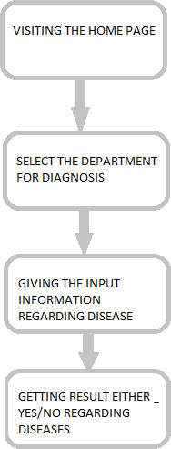

**Fig- 4.2.1: Flow Chart**

##### Purpose

The purpose of this project is to develop an AI-powered diagnostic support system that aids medical practitioners in the early detection of chronic diseases, specifically cancer, heart disease, and diabetes. By leveraging advanced machine learning techniques, the system is intended to:

* Enhance diagnostic accuracy
* Improve patient outcomes
* Reduce the workload of healthcare professionals
* Enable timely intervention through real-time data analysis and risk assessment

##### Scope

The scope of the project includes:

* Utilizing sophisticated machine learning algorithms to analyze diverse patient data, including:
  + Medical history
  + Laboratory test results
  + Imaging data
* Creating a predictive model trained on multiple datasets to ensure high accuracy and generalizability
* Delivering real-time insights and risk assessments to support clinical decision-making
* Ensuring seamless integration with existing Electronic Health Record (EHR) systems
* Ultimately providing a reliable tool that supports diagnostic efficiency and boosts healthcare productivity

###### UML DIAGRAMS

UML (Unified Modeling Language) diagrams are standardized visual representations used to model the structure and behavior of a software system. They help developers and stakeholders understand, design, and document the system effectively. UML diagrams are mainly categorized into structural and behavioral types. Structural diagrams, like class diagrams, define the static parts of a system such as classes and their relationships. Behavioral diagrams, such as use case, sequence, and activity diagrams, illustrate the dynamic aspects like user interactions, data flow, and system processes. These diagrams are essential for planning and communication in software development. In the context of your AI-driven diagnostic support system, UML diagrams help in visualizing system components, user roles, and data processing flow, making the overall design more efficient and organized.

###### USECASE DIAGRAM

The AI-driven diagnostic system involves five primary actors: Patient, Doctor, AI System, Lab Technician, and Admin. Patients can submit health data and view their diagnostic reports. Doctors access

patient history, review AI-generated diagnoses, and provide feedback. The AI System automatically analyzes data, detects chronic diseases, and generates diagnostic reports. Lab Technicians are responsible for uploading medical test results and imaging data. Admins manage user accounts, configure AI parameters, and oversee system settings. Each actor interacts with the system through defined use cases, representing a clear workflow that enhances healthcare efficiency.

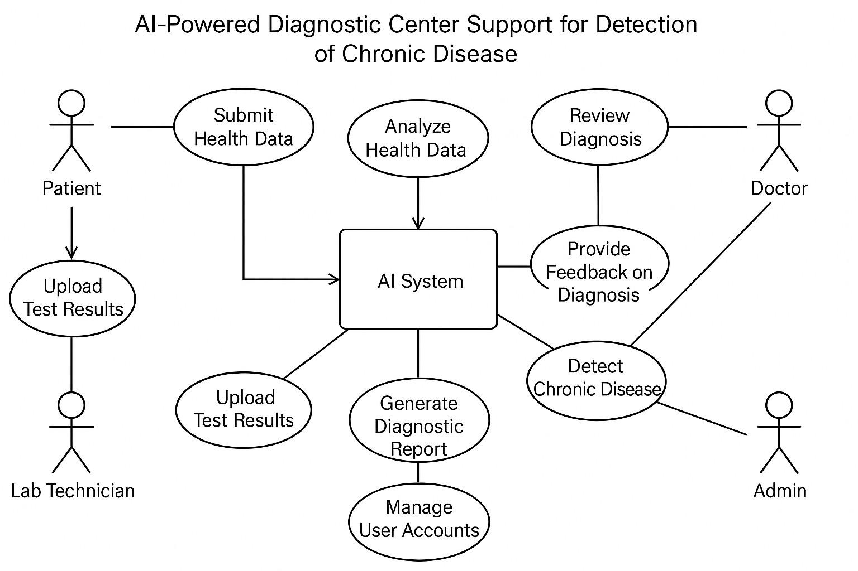

Fig 4.2.1 Use Case Diagram

###### SEQUENCE DIAGRAM

The Sequence Diagram visually outlines the suicide detection system's interaction flow. It depicts user input initiation, system analysis, and communication with the ML Model, summarizing the sequential process**.** In the system, the Patient begins by submitting their health data, which triggers the AI System to analyze and process the information. The Lab Technician uploads any necessary test results and medical imaging, which the AI system incorporates into its analysis for a more comprehensive understanding. Based on the data, the AI System generates a diagnostic report, which is then made accessible to the Doctor. The Doctor reviews the AI-generated report, verifies the diagnosis, and provides feedback. If necessary, the Doctor prescribes treatment based on the findings. Finally, the Admin is responsible for

managing user accounts, adjusting system settings, and configuring AI parameters to ensure the proper functioning of the platform.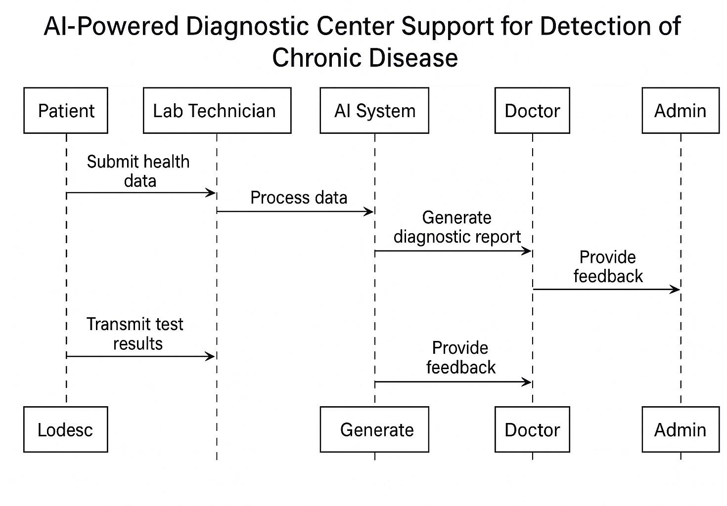

Fig 4.2.2 Sequence Diagram

**Creating a good User friendly interface**

**Developing the Web pages**

The web pages that we developed are home page, services page, about us page, login page, register page. Here the key web page is services page where we included 3 departments for diagnosis they are Cardiology, Diabetes, Liver Diseases.

**Detecting whether the person is affected by respective chronic disease**

**Import the Required Modules**: Importing Numpy,Pandas, MatplotLib,Seaborn,Scikit Learn,Keras for data handling, data analysis, data visualization, selecting a best model for prediction and numerical calculation.

**Installing Flask Framework:** Flask is a lightweight Python web framework used for building web applications and RESTful APIs. It offers simplicity, flexibility, and extensibility, making it ideal for small projects, prototyping, or scalable applications. With features like Jinja2 templating and support for extensions, Flask provides full control for developers to customize their applications.

**Data Collection and Data Preprocessing:** We collected data from kaggle, data bank and some records manually. Data preprocessing is done to the data we collected in order to eliminate noise, over fitting and handling categorical data and ranging the values by MinMax and Standard Scaler.

**Splitting Dataset into Training and Testing Data:** Split the dataset into training and testing dataset in the ratio of 80 : 20 by train_test_split() in sklearn.model_selection

**Initialize Machine Learning Model**: Initialize a pre-trained machine learning model. Set the parameter for machine learning model like random_state, max_features, n_estimators, min_sample_leaf for Random Forest, learning_rate, n_epochs and random_state for Logistic Regression.

**Evaluate Model Performance**: Model performance has evaluated in which for regression we used r2_score and for classification we used Confusion Matrix(Random Forest and Logistic Regression).

**Initiate app.py:** Here we need to run the app.py file to initiate the respective department file functionality.

**Give the inputs :** Here we need to give inputs by selecting the respective departments.

since for every chronic disease the factor or features may differ.

**Output**

**Getting the result:** The output is generated in the next page by showing where the person is affected by particular chronic disease or not

# IMPLEMENTATION

# AND

**RESULTS**

### 5. ​IMPLEMENTATION AND RESULTS

The implementation phase of the project involves transforming the theoretical design into a functional system. This includes developing a web application that utilizes machine learning algorithms to assist in the diagnosis of chronic diseases such as diabetes, heart disease, and liver disease. The implementation process is divided into several key steps:

1. Environment Setup:

* Hardware Requirements:
  + RAM: 8GB
  + Processor: Intel iCore
  + Hard Disk: 2TB
* Software Requirements:
  + Operating System: Windows
  + Libraries: NumPy, Pandas, Matplotlib, Seaborn, Scikit-Learn, Keras
  + Framework: Flask
  + Language: Python

1. Data Collection:

* Data was collected from various sources, including Kaggle datasets and manual records. The dataset includes patient medical history, laboratory test results, and imaging data.

1. Data Preprocessing:

* The collected data underwent preprocessing to handle missing values, normalize data, and convert categorical data into numerical formats. Techniques such as MinMax scaling and Standard Scaler were applied to ensure uniformity in data representation.

1. Model Development:

* Various machine learning models were implemented, including:
  + Logistic Regression
  + Random Forest Classifier
  + Support Vector Classifier (SVC)
  + K-Nearest Neighbors (KNN)
  + Gradient Boosting Classifier
* The models were trained on the preprocessed dataset, and hyperparameter tuning was performed using GridSearchCV to optimize model performance.

1. Integration with Flask:

* The application was developed using the Flask framework, allowing for the creation of a web interface where users can input their health details and receive diagnostic results.
* The web application includes several pages: Home, Services, About Us, Login, and Register, with a focus on the Services page for chronic disease diagnosis.

1. User Input and Output:

* Users can enter their health details through the web interface. The system processes this input and generates results indicating the likelihood of chronic diseases.
* The output is displayed on a new page, showing whether the user is affected by a particular chronic disease.

**SOURCE CODE- Diabetes**

import pandas as pd

from sklearn.model_selection import train_test_split from sklearn.preprocessing import StandardScaler

# Load the dataset (replace 'diabetes.csv' with your dataset path)

url = "https://raw.githubusercontent.com/jbrownlee/Datasets/master/pima-indians-diabetes.data.csv" column_names = [

"Pregnancies", "Glucose", "BloodPressure", "SkinThickness", "Insulin", "BMI", "DiabetesPedigreeFunction", "Age", "Outcome"

]

data = pd.read_csv(url, names=column_names)

# Display the first few rows of the dataset print(data.head())

# Check for missing values (if any) print(data.isnull().sum())

# Separate features (X) and target (y) X = data.drop("Outcome", axis=1)

y = data["Outcome"]

# Split the data into training and testing sets

X_train, X_test, y_train, y_test = train_test_split(X, y, test_size=0.2, random_state=42)

# Standardize the features scaler = StandardScaler()

X_train = scaler.fit_transform(X_train) X_test = scaler.transform(X_test)

**Heart Disease:**

import pandas as pd

from sklearn.model_selection import train_test_split

from sklearn.preprocessing import StandardScaler

# Load the dataset (replace 'heart.csv' with your dataset path)

url = "https://archive.ics.uci.edu/ml/machin e-learning-databases/heart-disease/pro cessed.cleveland.data"

column_names = [

"age", "sex", "cp", "trestbps",

"chol", "fbs", "restecg", "thalach", "exang",

"oldpeak", "slope", "ca", "thal", "target"

]

data = pd.read_csv(url, names=column_names, na_values="?")

# Handle missing values (if any) data = data.dropna()

# Separate features (X) and target (y)

y = data["target"].apply(lambda x: 1 if x > 0 else 0) # Convert to binary classification

# Split the data into training and testing sets

X_train, X_test, y_train, y_test = train_test_split(X, y, test_size=0.2, random_state=42)

# Standardize the features scaler = StandardScaler() X_train = scaler.fit_transform(X_train)

X_test = scaler.transform(X_test) "age", "sex", "cp", "trestbps",

"chol", "fbs", "restecg", "thalach", "exang",

"oldpeak", "slope", "ca", "thal", "target"

]

data = pd.read_csv(url, names=column_names, na_values="?")

# Handle missing values (if any)

# Separate features (X) and target (y) X = data.drop("target", axis=1)

y = data["target"].apply(lambda x: 1 if x > 0 else 0) # Convert to binary classification

# Split the data into training and testing sets

X_train, X_test, y_train, y_test = train_test_split(X, y, test_size=0.2, random_state=42)

# Standardize the features scaler = StandardScaler() X_train = scaler.fit_transform(X_train)

X_test = scaler.transform(X_test) from sklearn.ensemble import RandomForestClassifier

from sklearn.metrics import accuracy_score, classification_report, confusion_matrix

# Initialize the model model =

RandomForestClassifier(random_stat

=42)

# Train the model model.fit(X_train, y_train)

# Make predictions

y_pred = model.predict(X_test)

# Evaluate the model print("Accuracy:", accuracy_score(y_test, y_pred)) print("Classification Report:\n", classification_report(y_test, y_pred)) print("Confusion Matrix:\n", confusion_matrix(y_test, y_pred)) import seaborn as sns

import matplotlib.pyplot as plt

# Plot confusion matrix

cm = confusion_matrix(y_test, y_pred)

sns.heatmap(cm, annot=True, fmt="d", cmap="Blues") plt.xlabel("Predicted") plt.ylabel("Actual") plt.title("Confusion Matrix") plt.show()

**Liver Disease:**

import pandas as pd

from sklearn.model_selection import train_test_split

from sklearn.preprocessing import StandardScaler, LabelEncoder

# Load the dataset (replace 'indian_liver_patient.csv' with your dataset path)

url = ["https://www.kaggle.com/uciml/india](http://www.kaggle.com/uciml/india) n-liver-patient-records/download" data = pd.read_csv("indian_liver_patient.csv ")

# Display the first few rows of the dataset

print(data.head())

# Check for missing values print(data.isnull().sum())

# Handle missing values (if any)

data = data.dropna()

# Convert categorical 'Gender' column

to numerical

label_encoder = LabelEncoder() data['Gender'] = label_encoder.fit_transform(data['Gen der'])

# Separate features (X) and target (y) X = data.drop("Dataset", axis=1)

y = data["Dataset"].apply(lambda x: 1 if x == 2 else 0) # Convert to binary classification (1: Liver disease, 0: No disease)

# Split the data into training and testing sets

X_train, X_test, y_train, y_test = train_test_split(X, y, test_size=0.2, random_state=42)

# Standardize the features scaler = StandardScaler() X_train = scaler.fit_transform(X_train)

X_test = scaler.transform(X_test)

from sklearn.ensemble import RandomForestClassifier

from sklearn.metrics import accuracy_score, classification_report, confusion_matrix

# Initialize the model

model = RandomForestClassifier(random_state=42)

# Train the model model.fit(X_train, y_train)

# Make predictions

y_pred = model.predict(X_test)

# Evaluate the model

print("Accuracy:", accuracy_score(y_test, y_pred)) print("Classification Report:\n", classification_report(y_test, y_pred)) print("Confusion Matrix:\n", confusion_matrix(y_test, y_pred))

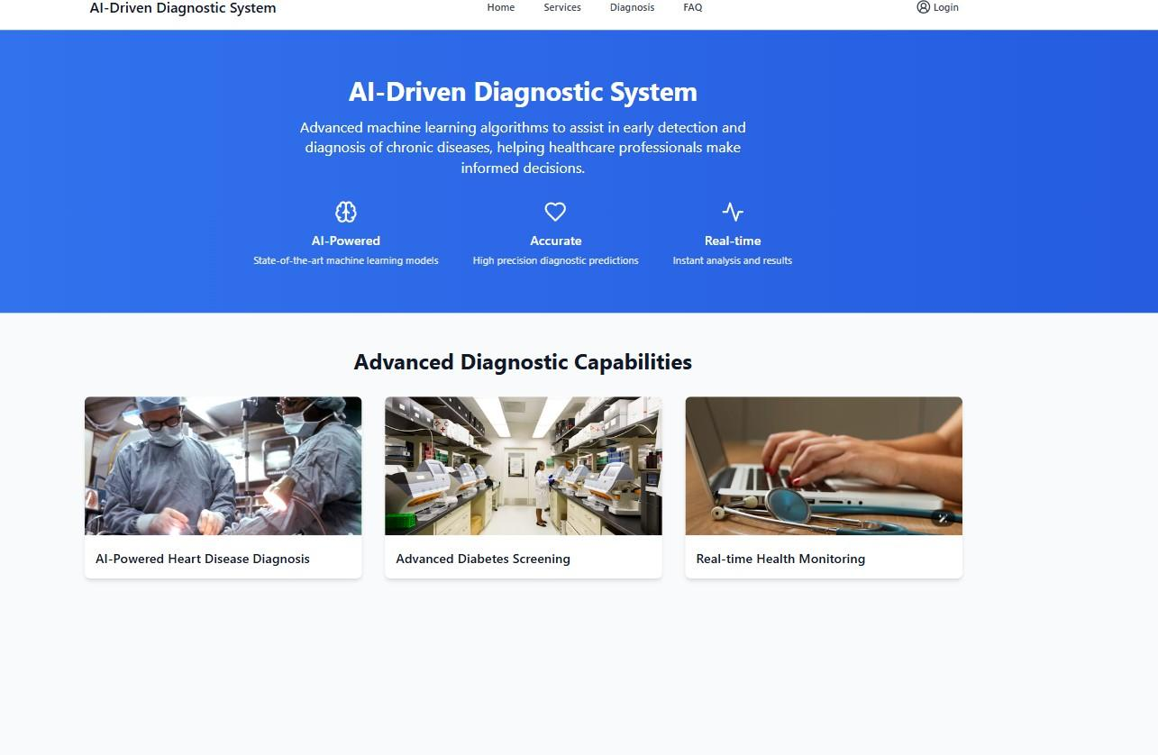

Fig 5.2.1 Home Page



Fig 5.2.2 Heart Disease Diagnosis Page



Fig 5.2.3 Heart Diseases Diagnosis Form

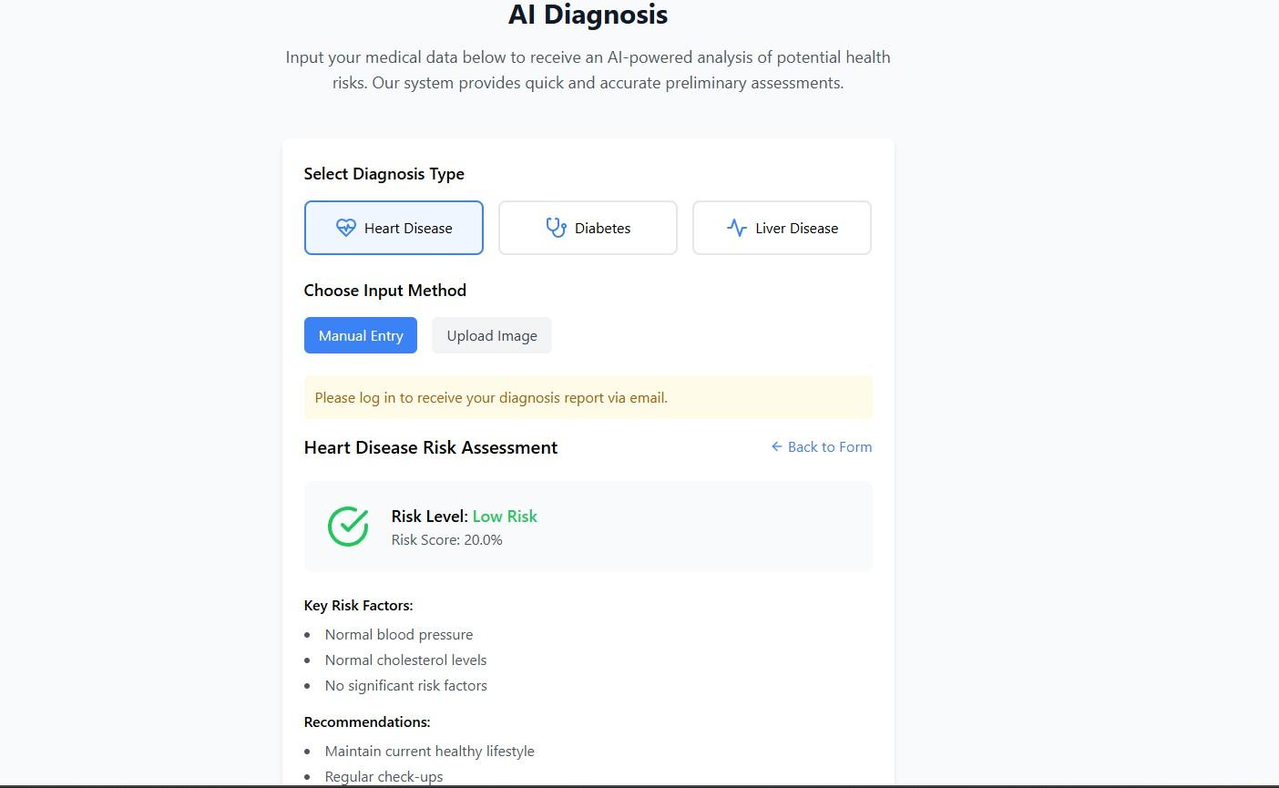

Fig 5.2.4 Heart Disease Diagnosis Output

# TESTING

# AND

# VALIDATION

### 6.TESTING AND VALIDATION

The system underwent rigorous testing to ensure functionality and reliability. Key testing strategies included:

* **Tool Selection Testing:** Verified that each tool (e.g., brush, line, circle) can be selected and used accurately.
* **User Interface Testing:** Ensured that the user interface displays relevant information clearly and updates in real-time.
* **Model Performance Testing:** Evaluated model accuracy using metrics such as sensitivity, specificity, and overall accuracy.

# CONCLUSION

# AND

**FUTURE ENHANCEMENTS**

### 7.CONCLUSION AND FUTURE ENHANCEMENTS

###### CONCLUSION

The project "AI Driven Diagnostic Center Support for Detection of Chronic Diseases" has successfully developed an innovative diagnostic assistance system that leverages artificial intelligence and machine learning to enhance the detection and management of chronic diseases such as diabetes, heart disease, and liver disease. By integrating advanced algorithms with a user-friendly web interface, the system provides healthcare professionals with timely and accurate diagnostic insights, thereby improving patient outcomes.

Key achievements of the project include:

1. **Enhanced Diagnostic Accuracy**: The implementation of various machine learning models has demonstrated significant improvements in diagnostic precision, reducing the likelihood of human error and enabling early detection of chronic diseases.
2. **Streamlined Workflow:** The system automates the analysis of complex medical data, alleviating the workload of healthcare professionals and allowing them to focus more on patient care and decision-making.
3. **User -Friendly Interface:** The web application is designed to be intuitive and accessible, facilitating easy interaction for both healthcare providers and patients.
4. **Integration with Existing Systems:** The seamless integration with electronic health record (EHR) systems ensures that the solution is scalable and can be adopted across various healthcare settings.
5. **Real-Time Data Processing:** The system's ability to process data in real-time allows for immediate insights, which is critical for timely clinical decisions.

Overall, this project highlights the transformative potential of AI in healthcare, paving the way for more efficient and effective chronic disease management. The successful implementation of this system not only addresses current diagnostic challenges but also sets the foundation for future advancements in AI-driven healthcare solutions.

###### FUTURE ENHANCEMENTS

While the current implementation has achieved significant milestones, there are several areas for future enhancements that could further improve the system's capabilities and user experience:

1. **Expanded Disease Coverage**: Future iterations of the system could include additional chronic diseases and conditions, such as respiratory diseases and autoimmune disorders, to broaden its diagnostic capabilities.
2. **Advanced Predictive Analytics**: Incorporating more sophisticated predictive analytics techniques, such as deep learning models, could enhance the system's ability to identify subtle patterns in patient data, leading to even earlier detection of diseases.
3. **Integration of Wearable Devices:** By integrating data from wearable health devices (e.g., smartwatches, fitness trackers), the system could provide continuous monitoring of patients' health metrics, allowing for proactive management of chronic conditions.
4. **Telemedicine Features:** Implementing telemedicine functionalities would enable healthcare providers to conduct virtual consultations, enhancing accessibility for patients in remote areas and improving overall patient engagement.
5. **User Feedback Mechanism:** Establishing a feedback loop where users can provide insights on the system's performance and usability would facilitate continuous improvement and adaptation to user needs.
6. **Enhanced Data Security:** As the system handles sensitive patient information, future enhancements should focus on implementing advanced security measures, such as encryption and multi-factor authentication, to ensure data privacy and compliance with regulations.
7. **AI Explainability:** Developing methods to improve the interpretability of AI models will help healthcare professionals understand the reasoning behind diagnostic suggestions, thereby increasing trust and adoption of the system.
8. **Collaboration with Healthcare Professionals:** Engaging with medical practitioners during the development process can provide valuable insights into clinical workflows and ensure that the system meets the practical needs of healthcare providers.

By pursuing these enhancements, the project can evolve into a more comprehensive and robust tool for chronic disease detection, ultimately contributing to improved healthcare outcomes and patient quality of life

# REFERENCES

### 8.​REFERENCES

1. Y. Huang, X. Liu, X. Zhang, and L. Jin, "A Pointing Gesture Based Egocentric Interaction System: Dataset, Approach, and Application," 2016 IEEE Conference on Computer Vision and Pattern Recognition Workshops (CVPRW), Las Vegas, NV. pp. 370-377, 2016.
2. Saira Beg, M. Fahad Khan and Faisal Baig, "Text Writing in Air," Journal of Information Display Volume 14, Issue 4, 2013
3. Yuan-Hsiang Chang, Chen-Ming Chang, "Automatic Hand-Pose Trajectory Tracking System Using Video Sequences", INTECH, pp. 132- 152, Croatia, 2010